**Memorandum**

To: Prof. Brandt

From: Group 9, Section A:

*Karan Rajwanshi, Jerry Yan, Maxwell Zhang, Xi Chen, Iris Cao*

Date: 02/13/18

***Question 1***

After a thorough analysis, we decide to perform a weekly basis evaluation on existing data. According to our back-test results, the optimal strategy to reduce our exposure from interest rate risk is to hedge our existing holding with 5-year coupon bonds. The outcome statistics are presented as follows.

The table below presents the hedging errors of different strategies, where hedging errors are calculated by finding the value difference between the preceding week and standing week.

|  |  |  |  |  |
| --- | --- | --- | --- | --- |
| Hed error | 7 vs 2 | 7 vs 3 | **7 vs 5** | 7 vs 10 |
| Mean | $23.012446 | $43.035636 | **$52.647141** | -$89.992327 |
| Std.ndev | 35016.88271 | 25379.07932 | **8816.699748** | 14005.37709 |
| Median | $2,129.28 | $1,605.32 | **$14.28** | -$146.69 |
| Max | $164,728.34 | $119,633.82 | **$60,240.50** | $71,777.72 |
| Min | -$161,648.70 | -$113,744.74 | **-$45,411.44** | -$93,870.27 |
| Skewness | -0.231596531 | -0.179699325 | **0.268979565** | -0.260692436 |

Although the two-year coupon 6% bonds appear to have lowest mean, its standard deviation also looked most desirable among all strategies, which suggests the variations across weeks are significantly large. Therefore, best strategy should take all factors into consideration. The five-year coupon bond only pertains lowest standard deviation but also lowest median, suggesting low variation in the timeframe. Five-year 5% coupon strategy also have a positive skewness, implying a relatively small exposure to tail risk. In contrast, other strategies tend to have negative skewness, indicating these hedging strategies might have asymmetrically greater amount of positive hedge error by chance.

Therefore, the back-test outcomes give us confidence in hedging interest risk with **five-year 5% coupon bonds.**

The summary of transaction cost for each strategy is presented in the following table.

|  |  |  |  |  |
| --- | --- | --- | --- | --- |
| Transaction | 7 vs 2 | 7 vs 3 | **7 vs 5** | 7 vs 10 |
| Mean | $149,267.7417 | $87,999.3046 | **$19,182.0332** | $21,778.6038 |
| Std Dev | 126986.3717 | 75136.73685 | **16173.45673** | 19275.05352 |

The results of transaction cost show that hedging with 5-year coupon bond only cost us 19K dollars of transaction fee on average. The 5-year 5% coupon bond also carries the lowest standard deviation in transaction cost. From cost-saving perspective, the optimal hedging strategy remains 5-year 5% Treasury Bonds.

***Question 2***

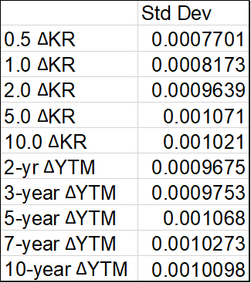

We began the analysis by looking at the standard deviation of various key rates and different coupon bonds. In theory, we prefer lower variation of YTM and Key rates. The above table suggests that longer maturity bonds tend to have a higher standard deviation of change in YTM, which is counter-intuition. To explain the abnormal trend demonstrated above, we found the volatility of short-term rate is extremely low since 2010 and to some extent dominates the variation of YTM change in shorter time frame. Conversely, the long-term YTM keep fluctuating in our observation horizon, such that the volatility of change in long-term bond yield is higher than short-term ones.

To take a close look at the impact of interest rate on different coupon bonds, we measured the correlation of YTM between various coupon bonds. As shown in the following graph, the yield changes are not perfectly correlated across maturities. In general, longer key rates tend to have lower correlation with the shorter key rates. For instance, the correlation between 0.5 years key rates and 1 year key rates are significant higher that the correlation between 0.5 years and 10 years key rates. The similar patterns appear in the changes of correlation between various coupon bonds’ YTM. The correlation between two-year 6% coupon bonds and three-year 12% coupon bonds is obviously higher than the correlation between two-year 6% coupon bonds and 10 year 8% coupon bonds.

#Table: correlation between changes in KR and YTM#

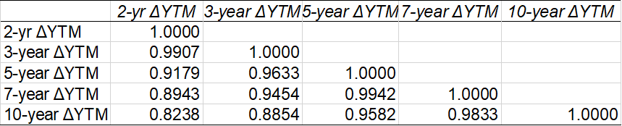

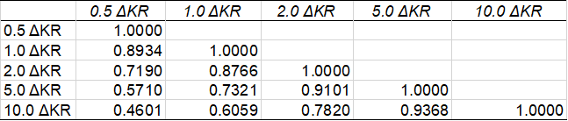

We somewhat worry about the inconsistency and imperfect correlation across different bonds, since the underlying assumption of our hedging strategy is that bonds with different time to maturity would have parallel reaction as interest rate changes. However, we deem that our optimal strategy pairing 5-year treasury bonds with 7-year treasury bond would have minimal impact from the interest rate changes, as the YTM correlation between 2 bonds are 0.9942.

***Question 3***

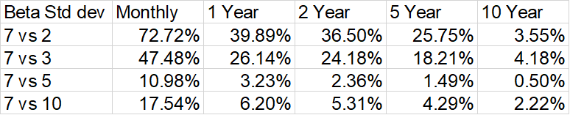

One way to get a more accurate hedge ratio is by using the regression-based risk weight. We performed our analysis on various rolling windows, specifically monthly, one-year, two- year, five-year, and ten-year. Beta standard deviation results are displayed in the table above.

In term of the window in rolling regression, we chose 2 years rolling basis, as we believe using historical data throughout last 2 year enables us to capture both fluctuation and seasonal trend. Since monthly basis or 10-year basis would lose fluctuation or seasonal trend respectively, as reflected in the above variation table of adjustment factors across different rolling windows, it is not desirable to use data either throughout last month or last 10 years. Besides, considering the time length of whole dataset, constructing 5-year rolling leads to waste in roughly a quarter of data, therefore, we chose 2-year rolling basis to obtain the balance between model effectiveness and data utilization.

***#Table: Statistics of different hedging strategy, std dev, mean and skewness#***

|  |  |  |  |  |
| --- | --- | --- | --- | --- |
| Hed Error(2YR) | 7 vs 2 | 7 vs 3 | **7 vs 5** | 7 vs 10 |
| Mean | 1536.65 | 1019.86 | **214.35** | -176.83 |
| Std dev | 33693.76 | 23753.03 | **8435.69** | 13815.68 |
| Skewness | -0.16 | -0.09 | **0.55** | -0.29 |
| Median | 2682.61 | 1983.40 | **161.58** | -186.81 |
| Max | 172033.93 | 130454.95 | **59121.82** | 76887.09 |
| Min | -167840.30 | -120911.01 | **-49512.37** | -97759.53 |

After 5 year rolling window is set, we retest our hedging strategies against new ratio.

The results are shown in the table below. We decide to stick with our original recommendation, hedging our portfolio with 5-year 5% coupon bond. Although the mean transaction fee is rises from 19182 to 27792, we still consider this an acceptable fee comparing to other strategies. As shown in the table, the 5-year coupon bond strategy still hold the lowest standard deviation.

***#Transaction cost evaluation***

|  |  |  |  |  |
| --- | --- | --- | --- | --- |
| Tran Cost(2YR) | 7 vs 2 | 7 vs 3 | **7 vs 5** | 7 vs 10 |
| Mean | 346445.6 | 168206.3 | **27792.94** | 31949.85 |
| Std dev | 537838.5 | 223090.4 | **30711.57** | 33618.43 |

***Question 4***

After reflecting on our analysis, we don’t think regression-based adjustment is necessary regarding in the specific circumstances. First of all, the volatility does not vary materially across different maturities. In fact, the 7-year coupon bond and 5 year coupon bonds is almost perfectly correlated. The difference of hedging error volatility between the adjusted strategy and week to week based strategy is within 400. In addition, difference between transaction fee is considerably inconsequential.

***Question 5***

The table below shows the historical key-rate DV01s and modified key-rate durations of all five coupon bonds with respect to each of the five key rates.

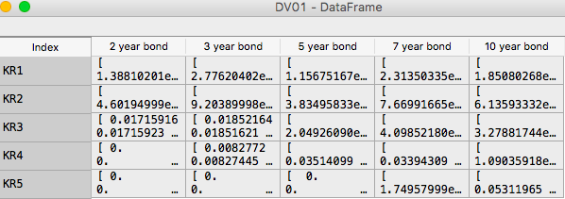

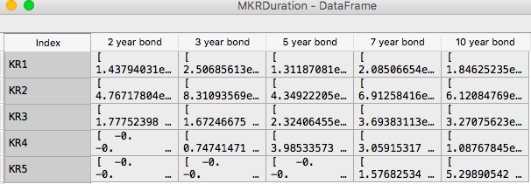

***Question 6***

*#Key Rate neutral portfolio (hedging on DV01s) #*

|  |  |  |  |  |  |
| --- | --- | --- | --- | --- | --- |
|  | 0.5 DV01 | 1.0 DV01 | 2.0 DV01 | 5.0 DV01 | 10.0 DV01 |
| 6-month Tbill | $0.0049 | $0.0000 | $0.0000 | $0.0000 | $0.0000 |
| 1-year T-bill | $0.0000 | $0.0097 | $0.0000 | $0.0000 | $0.0000 |
| 2-year coupon | $0.0001 | $0.0005 | $0.0197 | $0.0000 | $0.0000 |
| 3-year | $0.0003 | $0.0010 | $0.0223 | $0.0100 | $0.0000 |
| 5-year | $0.0001 | $0.0004 | $0.0025 | $0.0468 | $0.0000 |
| 7-year | $0.0002 | $0.0008 | $0.0049 | $0.0488 | $0.0257 |
| 10-year | $0.0002 | $0.0007 | $0.0039 | $0.0153 | $0.0897 |

We set our starting date on **2/2/2018**, and used a 6-month Treasury bill, a 1-year Treasury bill, the 2-year coupon bond, the 3- year coupon bond, the 5-year coupon bond, and the 10-year coupon bond to hedge the $10,000,000 face value of the 7-year coupon bond.

The linear system is listed in a table above, which illustrates the DV01 of the various coupon bond. Our optimization process is to hedge interest rate risk by solving the matrix consisting of 5 equations with 6 unknown variables, that is, setting y as the notional value times the DV01 for different key rates and calculating the notions for different maturity bonds that let y equal to zero in each key rate scenario.

|  |  |  |
| --- | --- | --- |
|  | Notion | Price |
| 6-month Tbill | -1112 | $99.18 |
| 1-year T-bill | -1935 | $98.16 |
| 2-year coupon | -0.00 | $107.54 |
| 3-year | -6688 | $128.15 |
| 5-year | -93542 | $111.67 |
| 7-year | 100000 | $147.35 |
| 10-year | -28714 | $146.28 |
| The total value we computed did not count in the value of cash the generated by shorting bonds. | Total Value  (Notion * Price) | -$1,068,562.28 |
| Transaction cost base  (ABS Notion * Price) | $30,537,976.72 |

Moreover, since the number of unknown variable is more than the number of equations, we will get a solution space. We assume that **there would be a transaction cost** when we construct the portfolio and the transaction cost should be determined by total transaction amount. To do optimization and get the best solution, we chose the **transaction cost minimization to be our objective and compute the optimal hedging strategy**, as we assume that the portfolio is first constructed at 2/2/2018 and original investment would be a good indicator of transaction cost. The linear combination can be solved using simultaneous matrix solver. The results of different notional values are presented in the following table.

*#Your expectation of portfolio value and reasons#*

Our duration-neutral strategy gains the goal to hedge all the interest rate risk through the horizon of maturity, which indicates the portfolio value remains unchanged no matter how interest rate varies in the future. Actually, since we got a solution space for key rate hedging, the portfolio value can be varying. Intuition tells us our portfolio should earn a return rate slightly more than the short term risk-free rate because our key rate hedging eliminates the interest risk from not only level risk perspective, but also the slope and curvature ones. The risks are hedged we should not get the interest rate level at 10% which has long-term interest rate risk exposure.